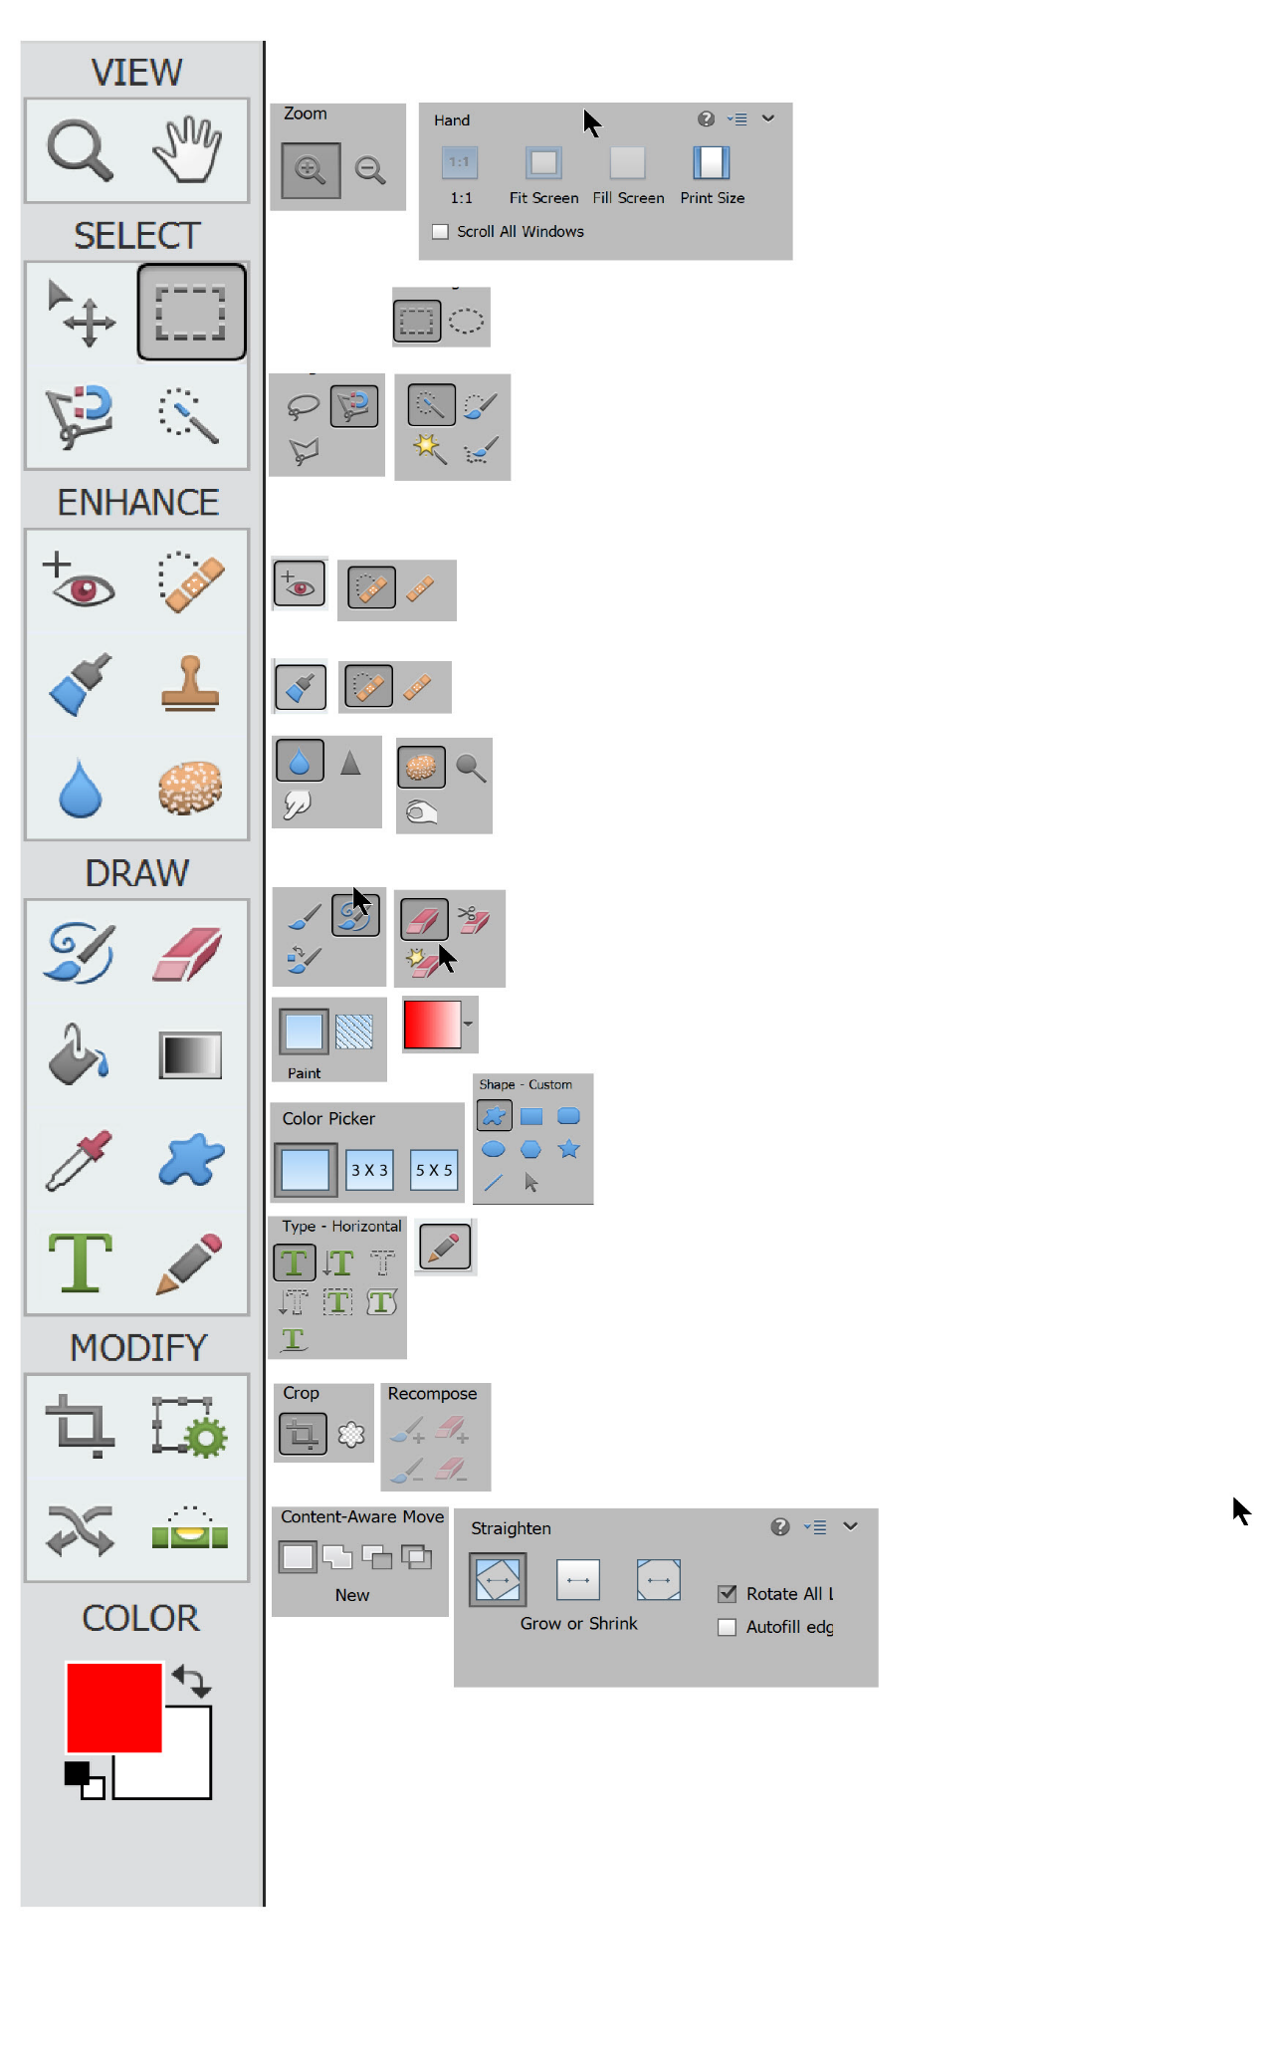
Photoshop 14 Elements Tools

